https://www.facebook.com/ktalk.utah/videos/1822093631421401/

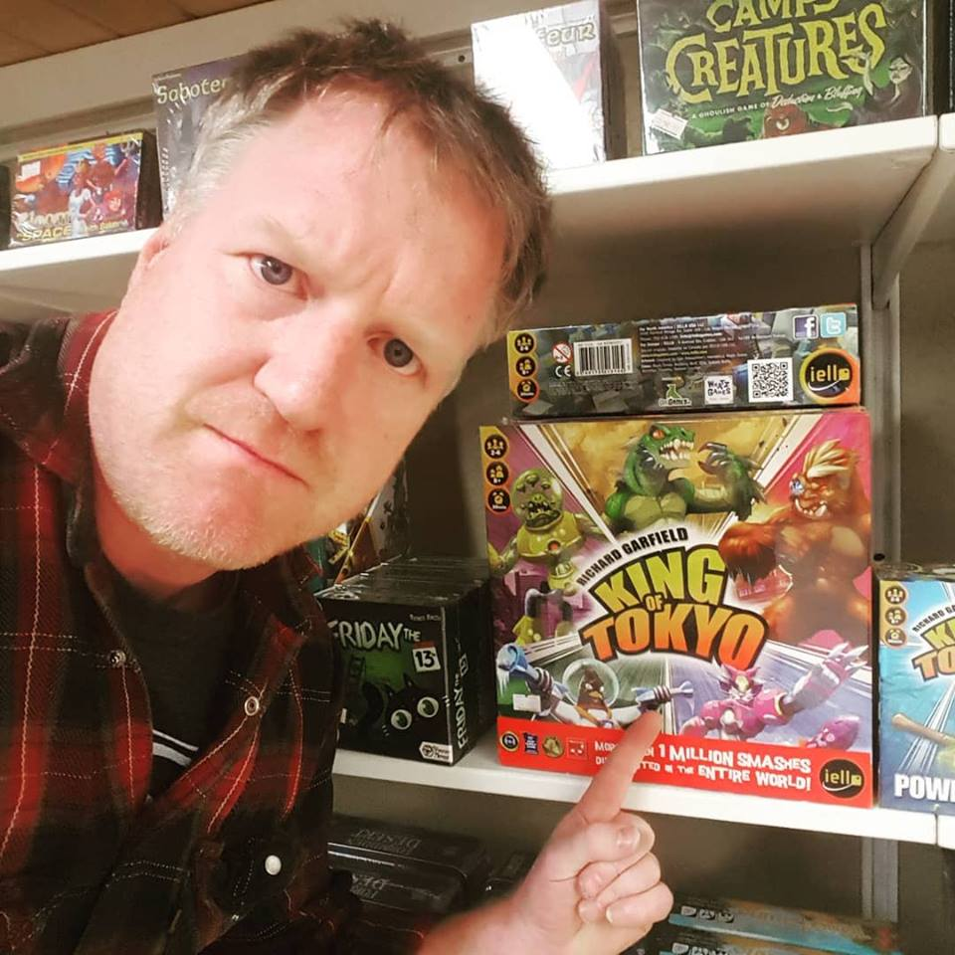 Video of game designer promoting new game.

 Picture posted of game designer showing off games in local store.



 A picture of a card, the game is coming out soon.

 A picture of a card, the game is coming out soon.

  A picture of a card, the game is coming out soon.